Use of BLOB’S->

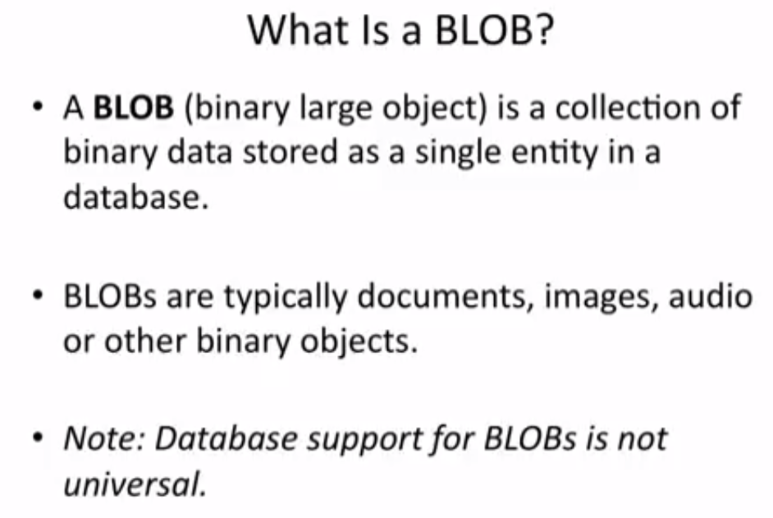

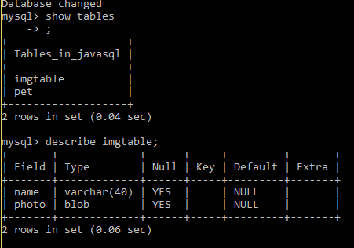

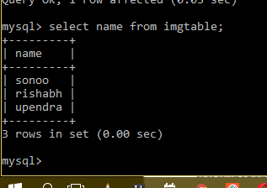

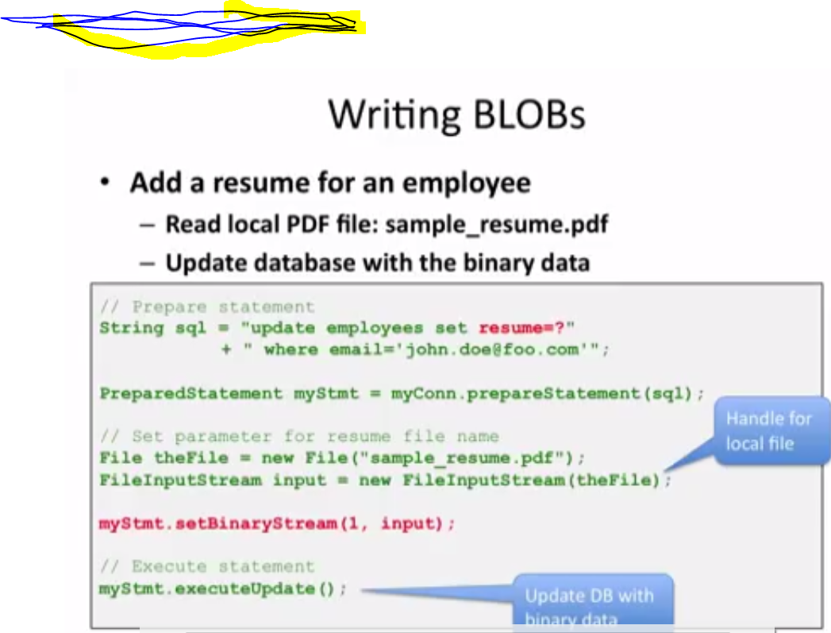

Here the sql query will be

All;

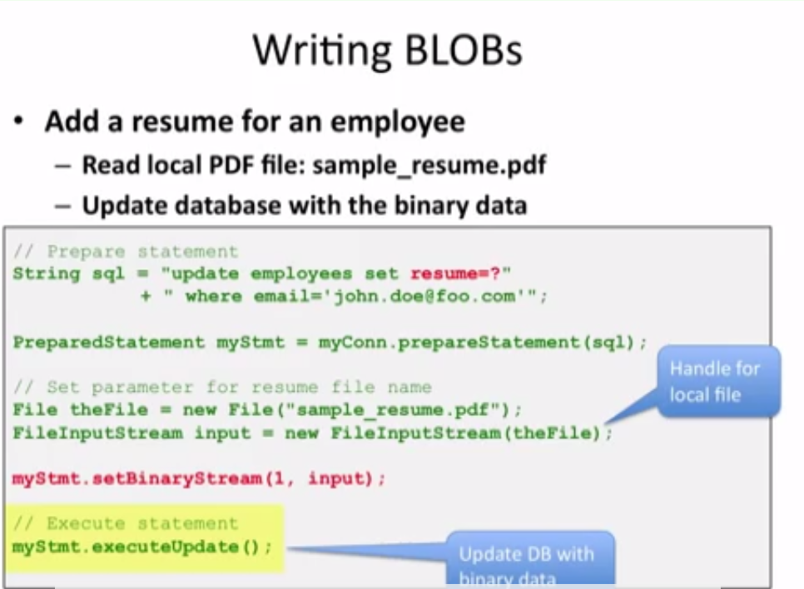

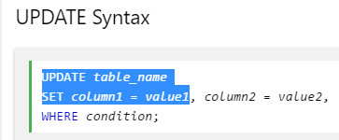

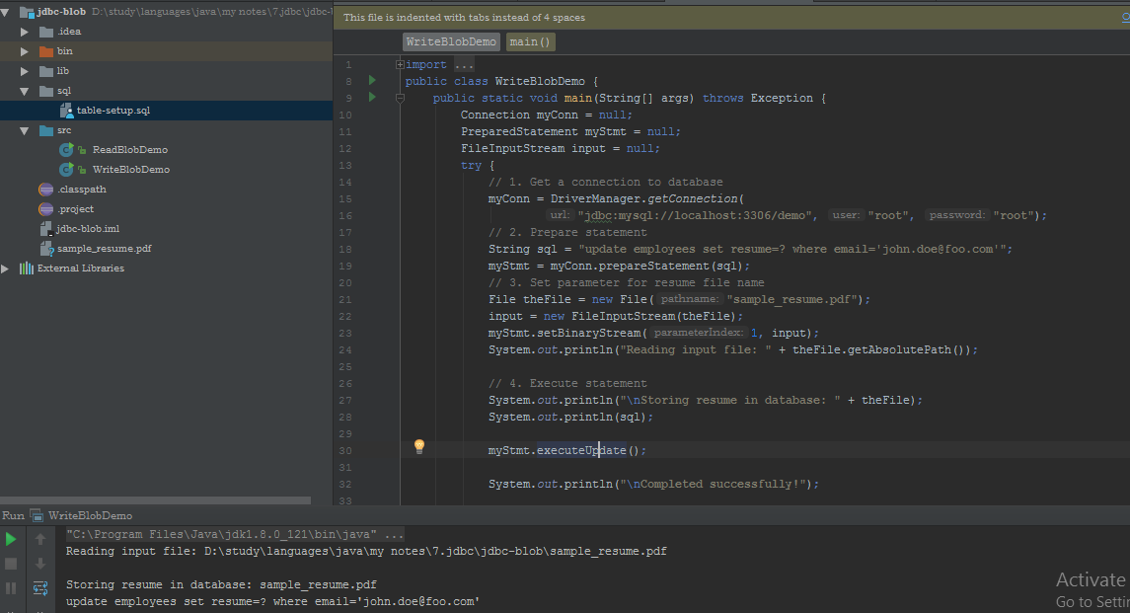

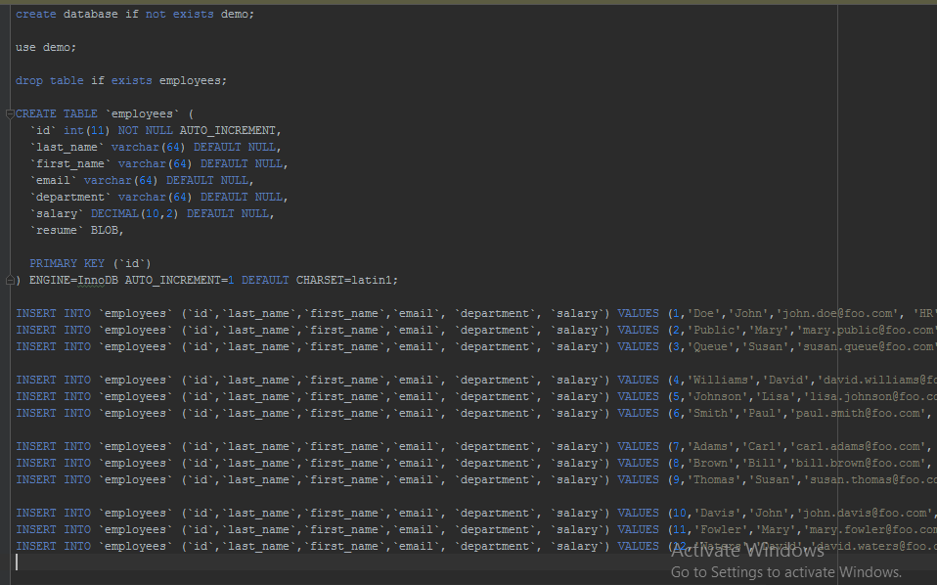

Now reading files in database->

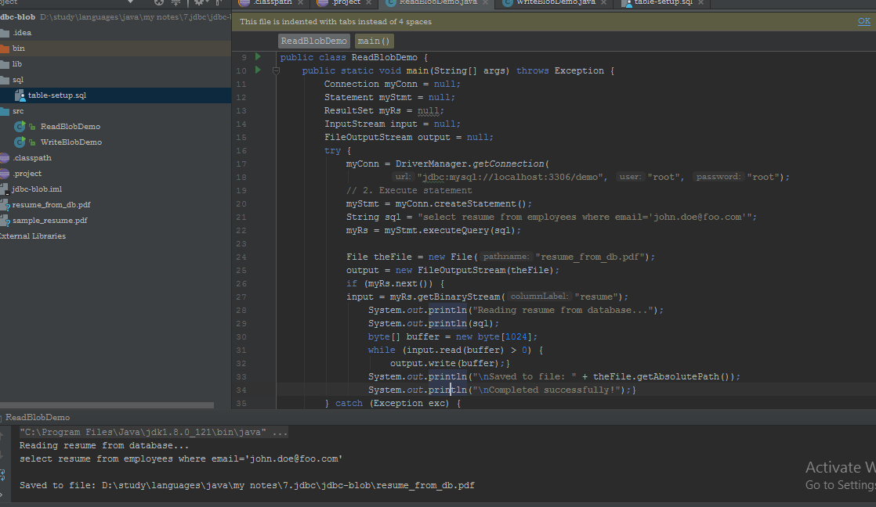

Example to store file in database:

The setCharacterStream() method of PreparedStatement is used to set character information into the parameterIndex.

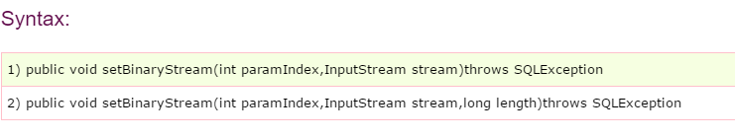

**For storing file into the database, CLOB (Character Large Object) datatype is used in the table. For example:**

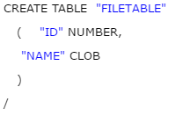

**Now I jus t make a pet table and store that elements->**

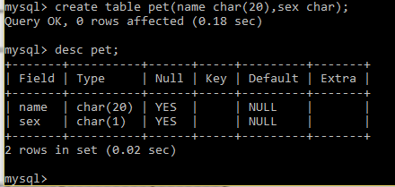

**And if we insert data manually then we take to much time instead of this we can retrieve data from file ;**

**After doing process**

**WRITING IN A DATABASE WITH THE HELP OF SQL;**

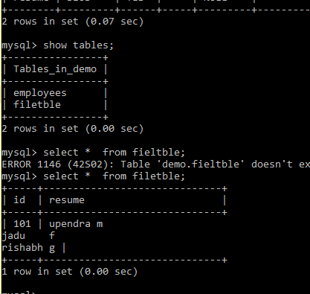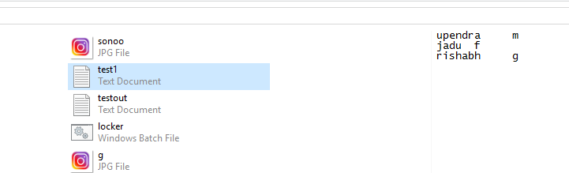

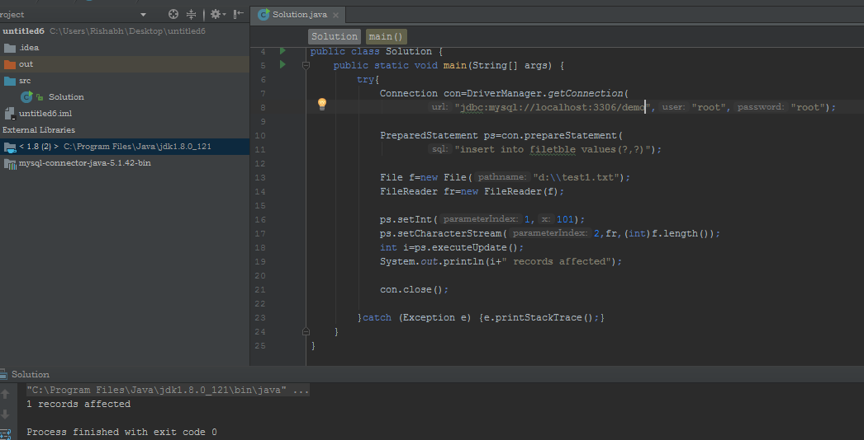

# Example to retrieve file from database:

**The getClob() method of PreparedStatement is used to get file information from the database.**

